**Class name:** HelpPlace

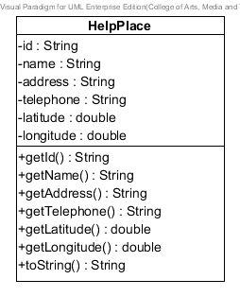

**Figure x: HelpPlace class**

**Entities**

|  |  |  |  |
| --- | --- | --- | --- |
| **ID** | **Name** | **Description** | **Type** |
| 1 | id | Store id of help place | String |
| 2 | name | Store name of help place | String |
| 3 | address | Store address of help place | String |
| 4 | telephone | Store telephone of help place | String |
| 5 | latitude | Store latitude of help place | double |
| 6 | longitude | Store longitude of help place | double |

**Class name:** HelpPlaceService

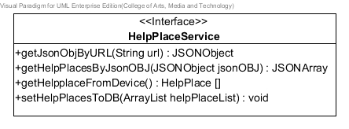

**Figure x: HelpPlaceService class**

**Method details**

**Method name:** getJsonObjByURL

public JSONObject getJsonObjByURL (String url)

**Description:** Get Json object by use url of server.

**Parameters:** url-string uses to get Json object file from server.

**Return:** Json object, if invalid input returns null

**Method name:** getHelpPlacesByJsonOBJ

public JSONArray getHelpPlacesByJsonOBJ (JSONObject jsonOBJ)

**Description:** Get Json array by use Json object that receive from getJsonObjByURL method.

**Parameters:** jsonOBJ-JSONObject uses to get Json array from getJsonObjByURL method.

**Return:** Json array, if invalid input returns null

**Method name:** getHelpPlacesFromDevice

public HelpPlace[]getHelpPlacesFromDevice ()

**Description:** Get help places from the user’s device that saved in file sqlite.

**Return:** HelpPlace array, if invalid input returns default sqlite file.

**Method name:** setHelpPlacesToDB

public void setHelpPlacesToDB (ArrayList <HelpPlace> helpPlaceList)

**Description:** Set help places into database of user’s device by input ArrayList for setting value of help place in offline map.

**Parameters:** helpPlaceList-ArrayList uses to set help place saved into sqlite file on database of user’s device.

**Class name:** HelpPlaceServiceImpl

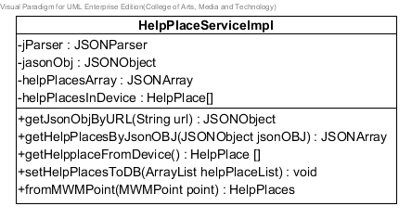

**Figure x: HelpPlaceServiceImpl class**

**Entities**

|  |  |  |  |
| --- | --- | --- | --- |
| **ID** | **Name** | **Description** | **Type** |
| 1 | jParser | Store JSON parser | JSONParser |
| 2 | jasonObj | Store JSON Object | JSONObject |
| 3 | helpPlacesArray | Store help places as JSON array | JSONArray |
| 4 | helpPlacesInDevice | Store help places to array | HelpPlace [ ] |

**Method details**

**Method name:** getJsonObjByURL

public JSONObject getJsonObjByURL (String url)

**Description:** Get Json object by use url of server.

**Flow:**

1. Set JSONObject equal to jParser to call getJSONFromUrl method and use url parameter.
2. Return jsonObj.

**Parameters:** url-string use to get Json object file from server.

**Return:** Json object, if invalid input returns null

**Method name:** getHelpPlacesByJsonOBJ

public JSONArray getHelpPlacesByJsonOBJ (JSONObject jsonOBJ)

**Description:** Get Json array by use Json object that receive from getJsonObjByURL method.

**Flow:**

1. Set helpPlaceArray variable equal to jsonOBJ to call getJSONArray method.
2. Return helpPlaceArray.

**Parameters:** jsonOBJ-JSONObject use to get Json array from getJsonObjByURL method.

**Return:** Json array, if invalid input returns null

**Method name:** getHelpPlacesFromDevice

public HelpPlace[]getHelpPlacesFromDevice ()

**Description:** Get help places from the user’s device that saved in file sqlite.

**Flow:**

Set for returning value of helpPlaceInDevice.

**Return:** HelpPlace array, if invalid input returns default sqlite file.

**Method name:** setHelpPlacesToDB

public void setHelpPlacesToDB (ArrayList <HelpPlace> helpPlaceList)

**Description:** Set help places into database of user’s device by input ArrayList for setting value of help place in offline map.

**Flow:**

Set for condition to set value into an array by use parameter array list.

**Parameters:** helpPlaceList-ArrayList use to set help place saved into sqlite file on database of user’s device.

**Class name:** HelpPlaceSingleton

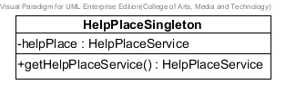

**Figure x: JSONParser class**

**Entities**

|  |  |  |  |
| --- | --- | --- | --- |
| **ID** | **Name** | **Description** | **Type** |
| 1 | helpPlace | Store HelpPlaceService object | HelpPlaceService |

**Method details**

**Method name:** getHelpPlaceService

public HelpPlaceService getHelpPlaceService ()

**Description:** Get HelpPlaceService with static value.

**Flow:**

1. Set helpPlace attribute to equal new HelpPlaceServiceImpl()
2. Return helpPlace.

**Return:** helpPlace object, if invalid input returns null.

**Class name:** JSONParser

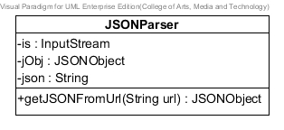

**Figure x: JSONParser class**

**Entities**

|  |  |  |  |
| --- | --- | --- | --- |
| **ID** | **Name** | **Description** | **Type** |
| 1 | is | Store value form data source | InputStream |
| 2 | jObj | Store Json object | JSONObject |
| 3 | json | Use for creating new object of JSONObject | String |

**Method details**

**Method name:** getJSONFromUrl

public JSONObject getJSONFromUrl (String url)

**Description:** Get Json object by receive url of server.

**Flow:**

1. Create object of DefaultHttpClient, HttpPost, HttpResponse, HttpEntity and set value to attribute “is” to use HttpEntity to get Content.
2. Use BufferReader to read InputStreamReader.
3. Keep value from readLine into StringBuilder append.

**Parameters:** url-string uses to get url of server.

**Return:** Json object, if invalid input returns null.

**Class name:** OnlineMapController

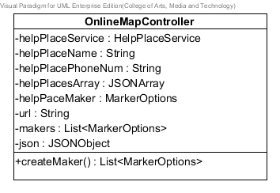

**Figure x: OnlineMapController class**

**Entities**

|  |  |  |  |
| --- | --- | --- | --- |
| **ID** | **Name** | **Description** | **Type** |
| 1 | helpPlaceService | Create help place service object | HelpPlaceService |
| 2 | helpPlaceName | Store name of help place | String |
| 3 | helpPlacePhoneNum | Store telephone number of help place | String |
| 4 | helpPlacesArray | Store help place in Json array | JSONArray |
| 5 | helpPlaceMaker | Create makerOptions object | MakerOptions |
| 6 | url | Store url of server | String |
| 7 | makers | Store makers in List of MarkerOptions | List<MarkerOptions> |
| 8 | json | Store Json object | JSONObject |

**Method details**

**Method name:** createMaker

public List<MakerOptions> createMaker ()

**Description:** Create maker with information of help place.

**Flow:**

1. Set value into helpPlacesArray variable by use getHelpPlacesByJsonOBJ method of HelpPlaceServiceImpl
2. Set string json variable to equal helpPlacesArray to use getJSONObject method
3. Set value to string helpPlaceName, helpPlacePhoneNum by use json variable to getString method.
4. Create createMaker method type List<MarkerOptions> to set information of help place into each maker.
5. Add helpPaceMaker variable that saved information into list of MakerOptions.

**Parameters:**

None

**Return:** MakerOption in array list, if invalid input returns null.

**Class name:** OffllineMapController

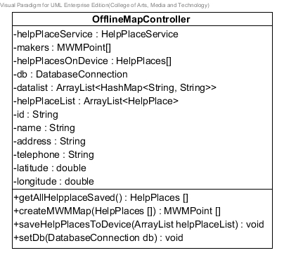

**Figure x: OfflineMapController class**

**Entities**

|  |  |  |  |
| --- | --- | --- | --- |
| **ID** | **Name** | **Description** | **Type** |
| 1 | helpplaceService | Create help place service ohject | HelpPlaceService |
| 2 | makers | Store MWMPoint object | MWMPoint [ ] |
| 3 | helpPlacesOnDevice | Store help place array | HelpPlaces [ ] |
| 4 | db | Store object class DatabaseConnection | DatabaseConnection |
| 5 | datalist | Store list of data in ArrayList | ArrayList<HashMap<String, String>> |
| 6 | helpPlaceList | Store list of help place in ArrayList | ArrayList<HelpPlace> |
| 7 | id | Store id of help place | String |
| 8 | name | Store name of help place | String |
| 9 | address | Store address of help place | String |
| 10 | telephone | Store telephone of help place | String |
| 11 | latitude | Store latitude of help place | double |
| 12 | longitude | Store longitude of help place | double |

**Method details**

**Method name:** getAllHelpplaceSaved

public HelpPlaces[] getAllHelpplaceSaved ()

**Description:** Get help places from database of user’s device.

**Flow:**

1. Initial value of helpPlacesOnDevice variable by use method getHelpplaceFromDevice of HelpPlaceServiceImpl.
2. Return help place array.

**Parameters:**

None

**Return:** HelpPlaces array, if invalid value returns null.

**Method name:** createMWMMap

public MWMPoint[]createMWMMap(HelpPlaces []hPlaces)

**Description:** Set help place maker to array.

**Flow:**

1. Initial value of maker variable by new object of MWMPoint. ]
2. Return maker of help place in array.

**Parameters:**

hPlaces-HelpPlaces use to set value to an array.

**Return:** MWMPoint array, if invalid input returns null.

**Method name:** saveHelpPlacesToDevice

public MWMPoint[]saveHelpPlacesToDevice(ArrayList <HelpPlace> helpPlaceList)

**Description:** Set help place maker to array.

**Flow:**

1. Initial value of maker variable by new object of MWMPoint.
2. Return maker of help place in array.

**Parameters:**

helpPlaceList-ArrayList<HelpPlace> uses to set value into setHelpPlacesToDB method of HelpPlaceServiceImpl.

**Class name:** InformationController

**Method name:** setDb

public void setDb(DatabaseConnection db)

**Description:** Set database in OfflineMapController class.

**Flow:**

1. Receive object in parameter
2. Set value to equal the attribute of DatabaseConnection object.

**Parameters:**

db-DatabaseConnection uses to set value to equal the attribute of DatabaseConnection object.

**Class name:** InformationView

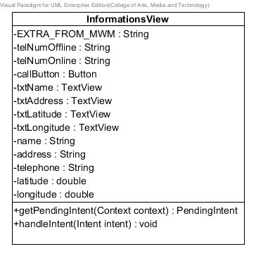

**Figure x: InformationView class**

**Entities**

|  |  |  |  |
| --- | --- | --- | --- |
| **ID** | **Name** | **Description** | **Type** |
| 1 | EXTRA_FROM_MWM | Store string “from-maps-with-me” | String |
| 2 | telNumOffline | Store telephone number of offline map | String |
| 3 | telNumOnline | Store telephone number of online map | String |
| 4 | callButton | Store value from telephone number to phone call button | Button |
| 5 | txtName | Store name of help place | TextView |
| 6 | txtAddress | Store address of help place | TextView |
| 7 | txtLatitude | Store latitude of help place | TextView |
| 8 | txtLongitude | Store longitude of help place | TextView |
| 9 | name | Store name of help place | String |
| 10 | address | Store address of help place | String |
| 11 | telephone | Store telephone of help place | String |
| 12 | latitude | Store latitude of help place | double |
| 13 | longitude | Store longitude of help place | double |

**Method details**

**Method name:** getPendingIntent

public PendingIntent getPendingIntent (Context context)

**Description:** Set pending intent value.

**Flow:**

1. Create Intent object to use InforamtionController.class as parameter.
2. Set intent to use putExtra method and input *EXTRA_FROM_MWM* as parameter.
3. Return PendingIntent to use getActivity method.

**Parameters:**

Context-Context uses for input as parameter to create Intent object.

**Return:** PendingIntent, if invalid input returns null.

**Method name:** handleIntent

public void handleIntent(Intent intent)

**Description:** Set information of help place that selected by handle.

**Flow:**

1. Use intent to getBooleanExtra method in if condition
2. Create MWMResponse object for using extractFromIntent method.
3. Set helpPlace variable to equal HelpPlaceServiceImpl.*fromMWMPoint*(response.getPoint());
4. Check helpPlace not null to set text into Text View.

**Parameters:**

intent-Intent use to get and set value.

**Class name:** PhoneCallListener

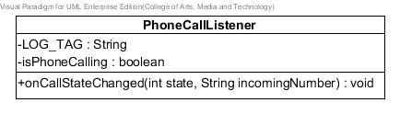

**Figure x: PhoneCallListener class**

**Entities**

|  |  |  |  |
| --- | --- | --- | --- |
| **ID** | **Name** | **Description** | **Type** |
| 1 | LOG_TAG | Use for test Log status | String |
| 2 | isPhoneCalling | Use to check state of TelephonyManager | boolean |

**Method details**

**Method name:** onCallStateChanged

public void onCallStateChanged (int state,String incomingNumber)

**Description:** Set state of phone call.

**Flow:**

Defind condition to check TelephonyManager state (*CALL_STATE_RINGING*, *CALL_STATE_OFFHOOK, CALL_STATE_IDLE*)

**Parameters:**

state-integer uses check compare with TelephonyManager state.

incomingNumber-String uses to set telephone number.

**Class name:** DatabaseConnection

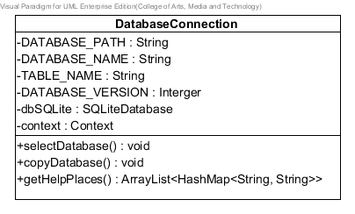

**Figure x: DatabaseConnection class**

**Entities**

|  |  |  |  |
| --- | --- | --- | --- |
| **ID** | **Name** | **Description** | **Type** |
| 1 | DATABASE_PATH | Store path of file SQLite | String |
| 2 | DATABASE_NAME | Store name of file SQLite | String |
| 3 | TABLE_NAME | Store name of table in database | String |
| 4 | DATABASE_VERSION | Store number version of database | Integer |
| 5 | dbSQLite | Store command to use database | SQLiteDatabase |
| 6 | context | Store context to call getAssets() | Context |

**Method details**

**Method name:** selectDatabase

public void selectDatabase ()

**Description:** Select database to use getWritableDatabase method to set dbSQLite.

**Flow:**

Set value into dbSQLite variable equal to this.getWritableDatabase method.

**Parameters:**

None

**Method name:** copyDatabase

public void copyDatabase ()

**Description:** Copying database from resource SQLite

**Flow:**

1. Create variable InptStream and OutputStream are null.
2. Use context to call getAsset method to open database.
3. Use while condition for InputStream reading buffer

**Parameters:**

None

**Method name:** getHelpPlaces

public ArrayList<HashMap<String,String>> getHelpPlaces ()

**Description:** Copying database from resource SQLite

**Flow:**

1. Write command to get information from database “Select * from (name of database)”
2. Set value to some variable by use cursor getString method for putting into HashMap.
3. Put HashMap into array list.
4. Return an array list.

**Parameters:**

None

**Return:** Array list, if invalid value returns null.